Lab 4 - Port Reading

Alexander Stradnic - 119377263

1. I set up the LEDs and cables as needed.
2. I then took a picture of each scenario, for when 2 adjacents are on, 2 are off, and no adjacents are either on or off.

# Code

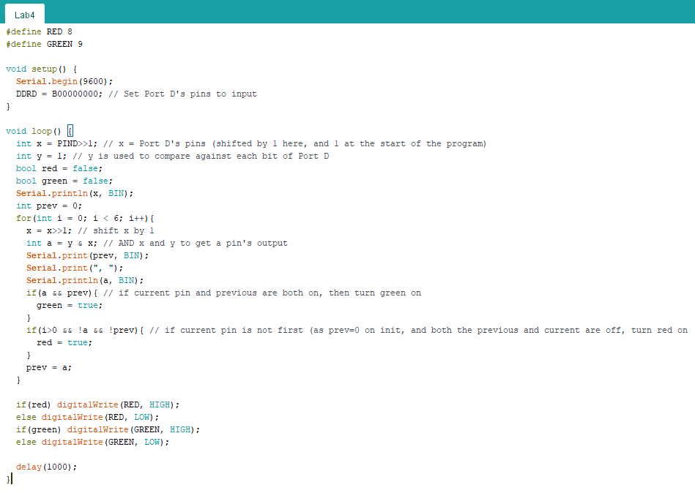

# Pictures

### All of the pins are off, thus (at least 2 adjacents off) the red LED is on.

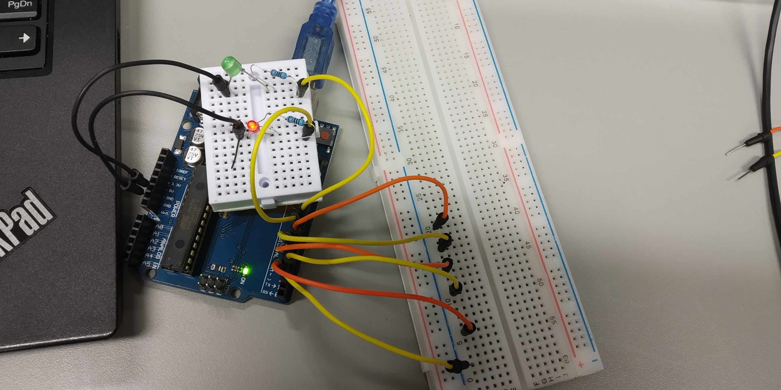

### All pins are on, thus (at least 2 adjacents on) the green LED is on.

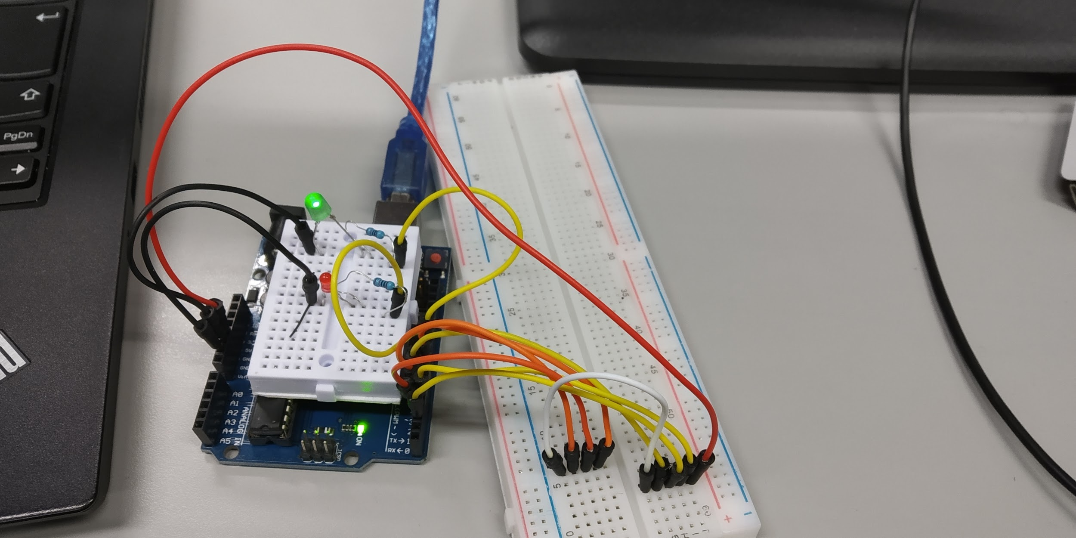

### Pins 2 and 3 are on, and the rest are off, thus (>=2 adj. on, >=2 adj. off) both LEDs are on.

### The odd pins are on, and evens off, thus (<2 adj. on, <2 adj. off) neither LED is on.

